Theme. (kindly help us choose one and develop on it)

* Plans are useless but planning is indispensable
* Plans are only good intentions if they are monitored and evaluated
* New developments and challenges in Monitoring and evaluation

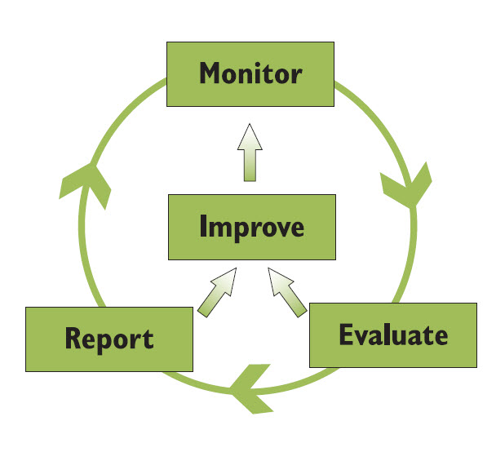

Introduction

Organizations are placing greater emphasis on measuring for results, looking for evidence of impact, justifying effectiveness and responding to a growing demand for accountability. In response to this perennial challenge in getting measurements right Capacity Africa is bringing the international community to share their experiences, approaches and review new initiatives in the monitoring and evaluation.

Objectives

* Understand the principles underlying the selection of an appropriate design for program evaluation and monitoring
* Understand how to design research tools, identify data sources and methods used to acquire information, to assess program impact
* Able to design a strategy to monitor a program and/or assess impact
* Critically analyze both the opportunities and the limitations that emerge when working with digital technology for program monitoring and evaluation.

Topics

1. Understanding and distinguishing between monitoring and evaluation
2. Governance and accountability
3. Selection of analytical tools, methodologies and approaches enabling measurement and attribution.
4. Development of indicators to measure progress and identity gaps
5. Logical framework approach (Log Frame) and results framework approach
6. Qualitative and quantitative data collection methods
7. Feeding monitoring and evaluation findings into decision-making
8. Developing indicators to measure progress and identify gaps
9. Budgeting for monitoring and evaluation
10. Managing monitoring and evaluation processes
11. Problem identification
12. Anticipating and resolving problems
13. Evaluation and good governance
14. Participatory planning and evaluation
15. Annual reviews and reports
16. Ethics in monitoring and evaluation